**Clinical Considerations**

Updated 25 March 2020

[**Anticipated Clinical Scenarios**](https://e-vent.mit.edu/clinical/#anticipated)  
[**Minimum Parameter Set**](https://e-vent.mit.edu/clinical/#min)  
[**Mechanical Ventilation 101**](https://e-vent.mit.edu/clinical/#101)  
[**Operating Modality**](https://e-vent.mit.edu/clinical/#ops)  
[**Additional Clinical Insights**](https://e-vent.mit.edu/clinical/#addl)

This section guides the engineering design with a focus on safety.

*Caution: This section****MUST****be read and understood fully first. No engineering team should consider designing a ventilator without a clinician experienced in mechanical ventilation and respiratory management involved.*

For a summary of key ventilation specifications, referencing this document, see [**Key Ventilation Specifications**](https://e-vent.mit.edu/clinical/key-ventilation-specifications/).

The MIT E-Vent is intended for emergency use only when all available conventional invasive respiratory support has been exhausted. It should only be used in a clinical environment under careful monitoring by trained medical professionals. This has been developed by a team of physicians certified in Anesthesia and Critical Care, working with mechanical, electrical, and software engineers. There were two critical tasks which we started with:

1. **Identify potential use scenario**s
2. Define the **minimum safe clinical functional** **requirements** (specs)

To minimize time to bedside without compromising patient safety, the clinical functional requirements were distributed to a broad team of clinical advisors. In parallel, a [**peer-review**](http://web.mit.edu/2.75/resources/random/Graham%20Peer%20Review%20Process.pdf) process was used to identify what was felt to be the best design concept (in spirit, loosely based on a prior [**student project**](https://e-vent.mit.edu/wp-content/uploads/2020/03/DMD-2010-MIT-E-Vent.pdf) which was not clinically validated). Once a review of the clinical functional requirements was completed, it was distributed to the design and controls teams.

We hope that this website can act as a reference point to help others and encourage discussion. Also, it is intended as a resource for makers or manufacturers to access and utilize the latest design. As it stands, several important tasks remain:

1. FDA review and feedback, work towards approval
2. Long-term (days) porcine trials
3. Implement design for manufacturing
4. Logistics for manufacture, distribution, and quality controls

**Anticipated Clinical Scenarios**

Specific to the present COVID-19 pandemic, we anticipate the following scenarios in which an emergency mechanical ventilator could be safely used to provide respiratory support:

* A deteriorating COVID-19 patient, who is short of breath & hypoxic; hypoxemic respiratory insufficiency means they are not breathing well enough to adequately oxygenate their blood. Clinicians at this point can initiate respiratory support. An MIT E-Vent could provide basic respiratory support in this situation
* Worsening clinical status recognized when a patient develops Acute Respiratory Distress Syndrome (ARDS), as a bridging solution until a traditional ICU ventilator becomes available
* The patient will be intubated or have a tracheostomy (limited / no applicability to mask)
* Those patients are otherwise going to be sedated and paralyzed (invasive ventilation requires sedation and paralysis will prevent patient-ventilator dyssynchrony until assist-control mode is implemented)
* Ventilated patients required to leave the ICU for imaging or procedures can be supported with the MIT E-Vent, unless determined that the patient requires support outside its range.

A multidisciplinary team consisting of a physician, critical care nurse, and respiratory therapist should be available to monitor ventilated patients at all times. Additionally, a clinical lab capable of timely reporting of blood gases and other common ICU laboratory markers should be available to enable the clinical team to make appropriate decisions and adjustments.

**Acute Respiratory Distress Syndrome**

Those patients with ARDS would preferentially receive mechanical ventilation by standard ICU ventilators. An AAMR is meant as a backup should institutions run out of traditional ventilators, and for patients with milder forms of lung disease that require less sophisticated modes and features.

Changes in lung mechanics (compliance) can be a result of acute and chronic lung conditions. In general, lung compliance is affected by a multitude of factors; in ARDS, fluid present in the alveoli and/or interstitial space (between the alveoli and a capillary blood vessel) and results in changes in the diffusion of gases between the alveoli and blood vessel. Other sources include:

* Any pathologies that cause fluid accumulation in the lung (‘wet lung’) through infectious, inflammatory, mechanical, or hydrostatic factors (pulmonary edema, TRALI, pneumonia, pneumonitis, diffuse alveolar hemorrhage, heart failure, cardiogenic shock, mitral valve regurgitation)
* Any pathology that causes fibrosis (scarring and thus stiffening – ‘stiff lung’) of the lung structure, otherwise known as the “parenchyma” (ARDS related, interstitial lung disease, sarcoidosis, idiopathic pulmonary fibrosis, radiation or chemotherapy-related, post pneumonia or hemothorax related trapped lung or lung fibrosis)

The safe limit for ventilation therapy has not yet been determined. In the life-and-death situation we are currently facing, this will give patients a chance until an ICU or OR ventilator becomes available. We are actively engaging with animal testing laboratories to determine what, if any, these limitations may be. Further, we plan to perform multi-day trials in pigs to evaluate the safety of longer-term MIT E-Vent use.

**Clinical Mechanical Ventilation 101**

If we boil down how a modern ICU ventilator works, there are three important parameters.

1. Tidal volume (air delivered to the patient)
2. Inspiratory phase start (“triggering”)
3. Expiratory phase start (“cycling”)

Each of these values is first determined by the machine and healthcare operator. Adjustments are made in real-time to optimize the patient’s clinical status, as measured by checking labs and monitoring vital signs. The patient acts as a “built-in” sensor!

**Tidal Volume: Volume-Control vs. Pressure-Control**

**Tidal volume**, one can set a specific volume in milliliters or set an inspiratory pressure on the mechanical ventilator; tidal volume is often discussed and thought about as a value based on cc/kg of ideal body weight (see Equation 1).  In **Acute Respiratory Distress Syndrome (ARDS)**, patients’ tidal volumes are kept between 4 to 8 cc/kg.  [**Here**](http://www.ardsnet.org/files/pbwtables_2005-02-02.pdf) is a convenient chart (PDF) provided by ARDSNet with values for ideal or predicted body weight and different tidal volumes corresponding to the patient’s height.

**Equation 1.** Gender-specific formulas to calculate ideal body weight (courtesy: [**ARDSNet**](http://www.ardsnet.org/files/pbwtables_2005-02-02.pdf)):

* Male Ideal Body Weight (kg) = 50 +[0.91 (height in cm – 152.4)]
* Female Ideal Body Weight (kg) = 45.5 +[0.91 (height in cm – 152.4)]

**Volume control mode** is just that: a clinician defines the tidal volume. The machine will then try to deliver that volume with a uniform inspiratory flow rate, over a specified inspiratory time (see discussion on cycling). This is done regardless of how much pressure builds up in the lungs, referred to as peak inspiratory pressure, or PIP. Modern ventilators have safety features to limit max pressures, which can result in damage to the lungs (aka barotrauma).  Ventilators have the capability to perform an “end-inspiratory hold”, for a programmable duration over which the pressure in the circuit is recorded.  This is called **plateau pressure (Pplat)**. A volume-controlled breath cycle with inspiratory hold is illustrated in Figure 1.

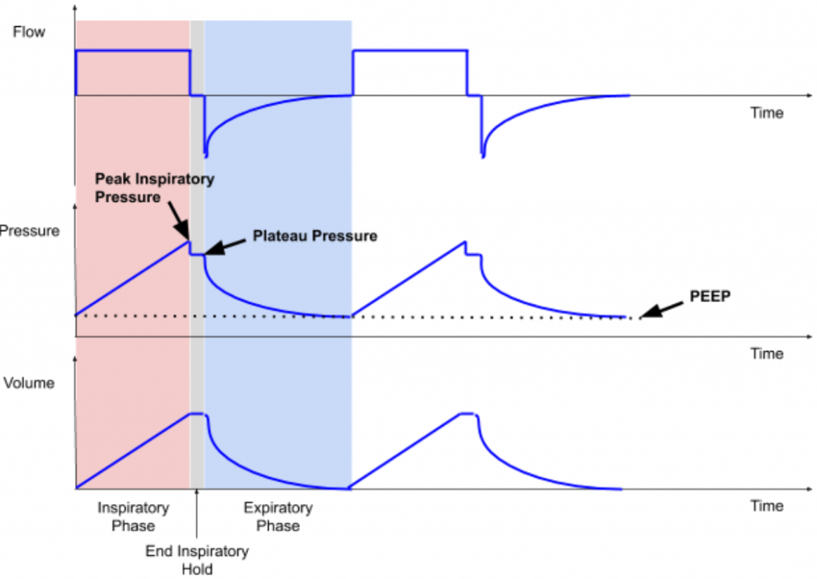**Figure 1:** Flow, Pressure, and Volume profiles for volume-control ventilation over 2 breath cycles; PEEP is illustrated on the Pressure plot. Image courtesy AK.

**Pressure control mode** utilizes pressure supplied by the ventilator, and the patient’s lung **compliance**and inspiratory time determine the volume of gas delivered (tidal volume). As we are actively [**learning more**](https://jamanetwork.com/journals/jamainternalmedicine/fullarticle/2763184) about patients with COVID-19, what we do know is that there is an [**ARDS-like**](https://www.thelancet.com/journals/lanres/article/PIIS2213-2600(20)30079-5/fulltext) clinical picture. Therefore we know that in COVID-19 patients the lung compliance changes with the disease course, and thus tidal volume will change with long-term use of pressure control ventilation.

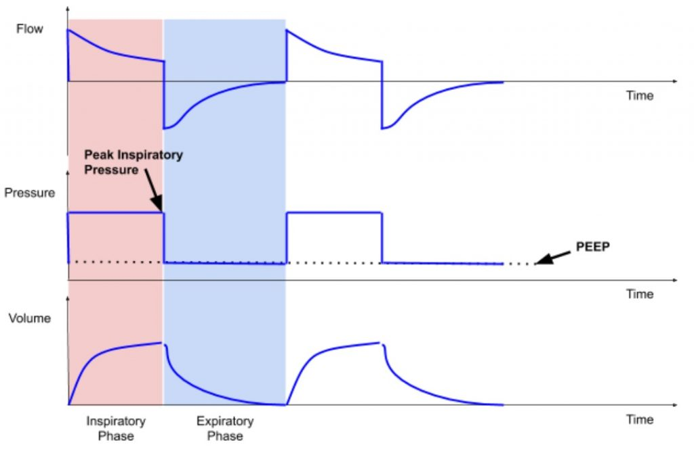**Figure 2:** Flow, Pressure, and Volume profiles for pressure-control ventilation over 2 breath cycles; PEEP is illustrated again on the Pressure plot. Image courtesy AK.

This presents another branch point for granular clinical details: **compliance** can be further broken down into that of the upper and lower airways. The upper airway consists of some structures bypassed by something like an endotracheal tube, namely the mouth, nose, oropharynx, and trachea. The lower airway consists of the bronchi (left and right mainstem, which further branch into secondary and tertiary bronchi, bronchioles, and alveoli). (**Figure**3) Compliance is also affected by the type of lung disease, grouped into restrictive or obstructive types, each further divided into extrinsic and intrinsic types. COVID-19 patients who development ARDS have an intrinsic, restrictive disease which requires additional baseline pressure to help “prop” open alveoli to maintain gas exchange. This is achieved by **positive end-expiratory pressure (PEEP)**.

**[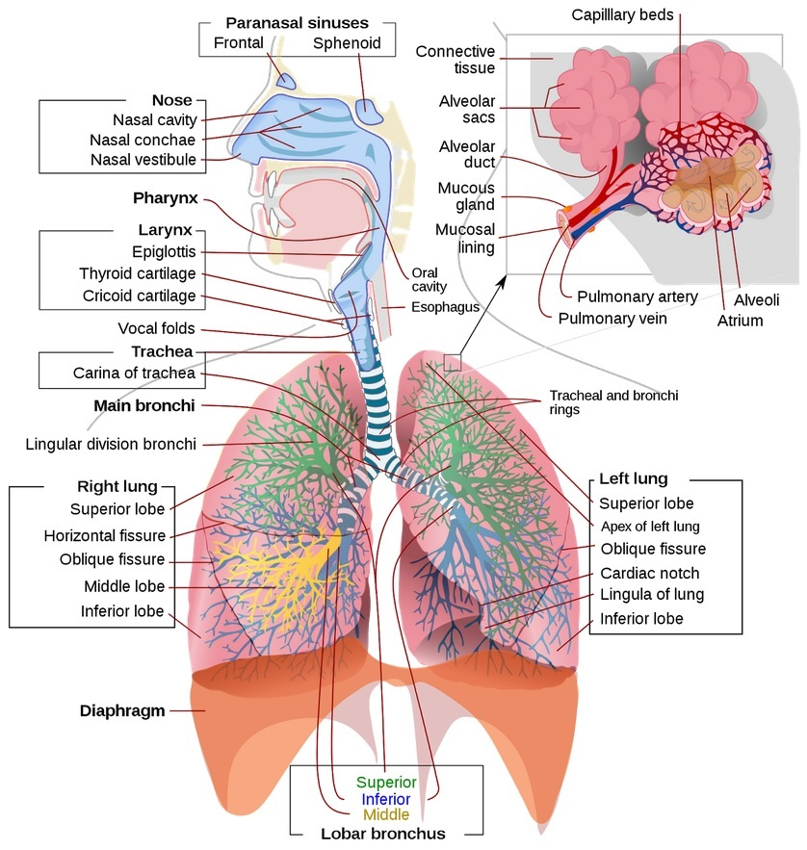](https://en.wikipedia.org/wiki/Respiratory_tract#/media/File:Respiratory_system_complete_en.svg)**Figure 3: Upper and lower human airway anatomy (Image courtesy Wikipedia)

**Inspiratory phase start: time / pressure / flow triggering**

Inspiratory phase can either be set to start at a regular interval by locking in a constant respiratory rate (e.g. **time triggering**) or have the ventilator sense the patient’s native inspiratory effort (with a pressure or flow sensor on the circuit), and time the start of the inspiratory phase according to the patient’s effort. This is analogous to oxygen pulse devices used by acrobatic plane pilots. Modern ICU ventilators can be set to trigger based on thresholds of **flow** (e.g. 1 – 4 L/min) or **pressure** (e.g. -1 – 5 cm H20) to initiate breaths. These are either inherent to a specific built-in ventilation mode (SIMV, PS, CPAP, etc; outside the present scope), or set by the clinical operator (respiratory therapist, nurse, CRNA, physician, etc).

Here, it should be noted that there is a difference between ICU ventilators and OR ventilators: ICU ventilators tend to be more advanced and are designed to care for patients who may require support for days, or weeks. OR ventilators are simpler and generally used on healthier patients for shorter periods of time (minutes to hours).

**Expiratory phase start: time / volume / flow / pressure cycling**

The start of the expiratory phase can be determined by different variables: time, volume, flow, and pressure.  Inspiratory phase duration can be programmed and expiration starts immediately after the time for inspiration is complete; this is called “**time cycling**.” In volume control, inspiration stops after the target inspiratory volume has been delivered; this is called “**volume cycling**.”  When inspiratory flow can be sensed, mechanical ventilator breath can switch from inspiration to expiration when the inspiratory flow reaches 10-25% of peak inspiratory flow; this is called “**flow cycling**.” Lastly, inspiration can be cycled into exhalation when a threshold pressure is reached.  For instance, if a patient coughs and becomes asynchronous with the ventilator, the airway pressure increases dramatically. This can be dangerous to the patient as ventilation is not effective when the patient is “fighting the vent.”  In this state, the ventilator switches inspiration to the exhalation phase and usually concurrently triggers the high-pressure alarm. This is called “**pressure cycling**.”

Additionally, in considering a single breath “cycle”, the ratio of time spent breathing in (inspiratory) vs. exhaling (expiratory) is important to consider as more time is required to fully exhale and prevent over-inflation (i.e. **breath stacking** or **auto-PEEP**). Inspiratory phase duration can be adjusted by altering the inspiratory to expiratory **(I:E) ratio** on the ventilator when a specific respiratory rate (bpm) is being used.

**Positive end-expiratory pressure (PEEP)**is applied in order to maintain an ‘open lung’, prevent alveolar collapse and thus improve gas exchange and minimize atelectrauma (repeated opening and collapse of alveoli “atelectasis” can also cause damage; the result of which is referred to as **atelectrauma**). In addition, due to the inhomogeneity of the lung tissues, positive pressure ventilation may lead to regional overdistention of alveoli (volutrauma and barotrauma), which can impair gas exchange and possibly further injure the diseased lung. The regional differences in lung compliance are dynamic and significantly change throughout a patient’s hospital course.

Depending on whether the patient or the machine determines each of the above parameters, different ventilatory modes are created.  Some examples include volume control, pressure control, assist control, pressure support, SIMV, and spontaneous modes. Full-feature ICU ventilators have other ventilatory modes available that better serve longer-term mechanical ventilation strategies.

**Minimum Parameter Set**

An automated mechanical ventilator should initially operate in volume control mode, with an initial rate, adjusting minute ventilation as the patient’s homeostasis is optimized with vital signs and lab draws. We envision two versions:

1. **Volume Control:** closed-loop delivery of a given tidal volume; closed-loop implies airway pressure sensing use for safety.
2. **Assist Control**: the system will sense airway pressure fluctuations, and supports patient-initiated breaths, and then recognizes and allows exhalation

In the simplest implementation, the system will be tuned using direct clinical observation and laboratory studies. This can serve as a transient device (e.g. for transport or bridge to more advanced ventilator) or as a definitive ventilator once demand outpaces available resources.

The minimum required hospital-supplied components are below, and harnesses existing infrastructure to increase scale-ability:

1. Manual resuscitator “Ambu” bag: different configurations; it is recommended that a pop off (pressure release) valve and PEEP valve (listed in alphabetical order, with no preference given for any model) are included in any circuit. Suggested models include:
   1. Ambu SPUR II Disposable Resuscitator (need to purchase PEEP valve adapter separately)
   2. CareFusion AirLife Adult Disposable Self Inflating Resuscitation Device (need to buy PEEP valve adapter separately)
   3. Teleflex Lifesaver Disposable Manual Resuscitator (Catalog #5374; pop-off valve and PEEP included)
   4. VBM Germany PVC Resuscitator Set (40 cm H2O pop off valve and PEEP valve included)
2. PEEP valve can be purchased separately if needed
   1. Ambu PEEP Valves
   2. CareFusion AirLife Adjustable PEEP Valves
3. Endotracheal (ET) and/or Tracheostomy tubes
   1. Follows ISO standards and have standardized connectors
4. Proper breathing circuit with proper valve mechanism at the patient end to minimize dead space and rebreathing of CO2
5. Short flexible connector to connect end of breathing circuit to ET/trach
   1. AirLife Omni-Flex Patient Connector
6. Oxygen / Air mixer if available (to adjust FiO2)
7. HEPA filter to remove virus particles from expired gases (optional; likely not required is patient in isolation).
   1. Thermovent HEPA Low Deadspace Heat and Moisture Exchange Filter

**Minimum Performance Parameters**:

|  |  |  |
| --- | --- | --- |
| *Parameter* | *Value or Range* | *Note* |
| Modes | Volume Control Assist Control Fail-safe | Recognize if patient stops breathing –> switch to default |
| Tidal volume | 200 – 800 mL 6 mL or less / kg (ideal patient weight) as start point | Must be adjustable |
| Rate | 8 – 40 or 10 – 40 breaths per minute | Must be adjustable |
| PEEP[1] (part) | 5 – 20 cm H20 | Must be adjustable |
| Plateau pressure | Threshold: 40 – 60 cm H20 ; achieve with valve (part) | Usually fixed depending on Ambu bag type |
| I/E (inspiratory/ expiratory ratio) | 1:2[3]; range of 1:1 – 1:4 COVID-19 patients are frequently requiring 1:3 and higher | Adjustable |
| Expired filtration | HEPA available as a component | Must be in line |
| Inspired filtration | HEPA available as a component | Must be in line |
| Inspired humidification | Combine with outgoing (self-humidification) | Recommended |
| Assist Control (breath detection) | Sense pressure of -1 to -5 cm H20 | Recommended – requires pressure transducer in design |
| FiO2 | 30%-100% | Recommended |
| Peak inspiratory pressure (PIP) | Will be set by pop off valve threshold in initial product. If pressure transducer is used to continuously measure airway pressure, can program to limit PIP | Fixed or Adjustable – requires pressure transducer in design |

[1] Not recommended to use gravity driven PEEP valve

Additional considerations are not defined based on things like necessary electrical supply or gas supply. We are assuming that units will be manufactured with good manufacturing practices and power provided with off-the-shelf or similar technology. Further, operating in an environment under the supervision of a physician gives the highest chance for safe treatment.

**Operating Modality**

* Patients will be intubated or have a tracheostomy
* PEEP pressure can be adjusted as per clinical judgment (typically started between 5-10cm H20).
* Respiratory rate is adjusted according to clinical needs. This will be available digitally or via mechanical adjustment. If not digitally set, the clinician will time the device using their watch.
* I/E ratio set digitally or via a mechanical adjustment, if available, but it can be fixed.
* Oxygen supply is connected to the bag. The inhaled oxygen fraction can be adjusted using a gas flow blender (mixing 100% oxygen & air (21% oxygen) according to the patient’s clinical status).
* ABVV connected to patient, patient observed and settings adjusted based on SpO2, clinical evaluation, etc.
* The tidal volume is ramped up by observing bag compression as per clinical judgment. Later the system can be calibrated for a particular bag brand and tidal volume will be initially set to the closest value to 6 cc/kg ideal body weight.

**Additional Clinical Insights**

* The simplest machine is capable of operating in volume control mode, which does not incorporate breath sensing, is applicable only to sedated & paralyzed patients.
* Non-paralyzed patients are unlikely to tolerate a machine that is not able to detect inspiration. Opinions differ, and a one-way inspiratory valve may be OK in a non-paralyzed patient: [**https://www.harvardapparatus.com/one-way-respiratory-valves.html**](https://www.harvardapparatus.com/one-way-respiratory-valves.html)
* When a patient does spontaneously try to breath, air must flow to avoid negative pressure generation, which in turn could lead to pulmonary edema and further worsen lung compliance and gas exchange. Most Ambu-bags have this as a default feature.
* An over-pressure (PIP) value is required, with an active alert based on a pressure transducer. An acceptable solution is to reduce inspired volume, and most patients will tolerate this.
* Adjustment of I/E ratio improves flexibility, but it is not essential and easier to do with digital control.
* Acute Respiratory Distress Syndrome (ARDS): based on clinical reports, COVID-19 patients who are intubated for invasive mechanical ventilation initially have relatively normal compliance, and normal driving pressures can be used (plateau pressure minus PEEP, with a goal of < 15cm H20). Lung compliance, however, often decreases with worsening ARDS.
* Must be labelled with a warning that the MIT E-Vent does not have standard sensing, alert, and safety capabilities.
* Even if limited oxygen is available, the MIT E-Vent can protect patients from self-inflicted lung injury (SILI). This is lung trauma caused by erratic respiratory patterns, large intrathoracic pressure swings, and shear injury between heterogeneous lung parenchyma in dyspneic patients with diseased lungs.

**42 Replies to “Clinical Considerations”**

1. 

[Duncan Kuhn](https://e-vent.mit.edu/user/kuhndm001/)

[22 March 2020 at 20:27](https://e-vent.mit.edu/clinical/#comment-17)

[Reply](https://e-vent.mit.edu/clinical/#comment-17)

Hi  
Below are some thoughts I had generated for another venue, but I think are relevant here. My understanding is current version is machine set/delivered breaths only (ie not sensing), which is problematic.

Short version is that forced breath-only machine is not a good solution, on multiple levels. It is much harder to maintain vent synchrony (because when the patient wants to pull a breath, they can’t), requires higher levels of sedation, and in turn generally means longer times on the vent. As an aside, this mode is called CMV or controlled (or continuous) minute ventilation.

The ventilation we usually use is AC/VC – this is assist control/volume control. It provides the breath at a backup rate, and if the patient wants to breath over, they can trigger then vent to give a breath. That is an “Assisted Breath” This is the mode we really need for patients with ARDS

Plenty of other thoughts, but for sake of staying on point will keep it to these for now. On a side not though, once patients are breathing spontaneously, ambu-bags are pretty problematic.

* + 

[A K](https://e-vent.mit.edu/user/kwon1102/)

[22 March 2020 at 23:14](https://e-vent.mit.edu/clinical/#comment-21)

[Reply](https://e-vent.mit.edu/clinical/#comment-21)

Thanks for your feedback. We do not think this ventilator would replace conventional ICU ventilators. When all conventional ventilators are being used in a hospital and there’s a critical shortage of mechanical ventilators, we think this ventilator could come into play and provide mechanical ventilatory support to COVID-19 patients until a conventional mechanical ventilator becomes available.

The control team is working on using the pressure sensor to implement AC/VC mode. Once successfully implemented, the team will share the methods. Until then, if a hospital needs to use this ventilator due to critical shortage, we think it’d be best for the patient to be paralyzed. Once AC mode is available, we will inform everyone.

* + 

[Tyler Harmon](https://e-vent.mit.edu/user/tharmon57/)

[23 March 2020 at 09:35](https://e-vent.mit.edu/clinical/#comment-26)

[Reply](https://e-vent.mit.edu/clinical/#comment-26)

Hey Duncan,  
These are all great points. I agree that the heavy level of sedation required for these designs could be problematic for patients who need AC/VC driven ventilation. My question is, could the proposed device work as a bridge device for patients who are waiting on a vent to be freed up? This may be its main mode of utility and could keep us out of the ‘Italy scenario’, especially in the field hospitals being set up by the Army Core of Engineers across the country. I don’t have a clinical background as you do so any feedback on the idea is appreciated!

* + 

[Rob Kirby](https://e-vent.mit.edu/user/kwicklyme/)

[24 March 2020 at 20:36](https://e-vent.mit.edu/clinical/#comment-86)

[Reply](https://e-vent.mit.edu/clinical/#comment-86)

How can I upload a file? We have contacted our Congressman and have received the recent release from the FDA which outlines what is allowed/required to allow the development of a ventilator.

* + 

[Sven Forsberg](https://e-vent.mit.edu/user/svenf/)

[26 March 2020 at 15:25](https://e-vent.mit.edu/clinical/#comment-131)

[Reply](https://e-vent.mit.edu/clinical/#comment-131)

From what I have read online, pressure control seems to be the way to ventilate patients with ARDS due to the changing lung compliance. This way, tidal volumes do not need to be adjusted over time. Have you considered pressure control? I imagine that this might be harder to implement using the current architecture, though.

* + 

[Richard Finney](https://e-vent.mit.edu/user/rijohael/)

[29 March 2020 at 11:02](https://e-vent.mit.edu/clinical/#comment-364)

[Reply](https://e-vent.mit.edu/clinical/#comment-364)

Discussion includes a mental picture of a Y connection of Inspiratory and Expiratory flow lines at connection to ET/Trach with a Proper Valve Mechanism to minimize dead space rebreathing of CO2. My suggestion is a transition to a coaxial (3D printable) joining of inspiratory and expiratory tubing, such device close to or even a part of ET/trach. One could even place a flapper valve (small version of those used in Mine Safety Administration approved respirators) at the end of the inner (inspiratory) coaxial feed, although the positive pressure of the feed should make this valve unnecessary. This suggestion is essentially that a coaxial joint (equal flow restriction in/out driving dimensions-diameters bases on cross sectional areas and lengths until transition to larger diameter feeds) rather than a Y joint will allow minimization of CO2 rebreath volume.

1. 

[Ben Moor](https://e-vent.mit.edu/user/drbenmoor/)

[22 March 2020 at 20:42](https://e-vent.mit.edu/clinical/#comment-18)

[Reply](https://e-vent.mit.edu/clinical/#comment-18)

I agree with Duncan on the problem of using any kind of mechanical Ambu-bag in a patient who is starting to breath spontaneously. The transition from a fully ventilated patient to one who needs support and finally weaning will be very difficult using anything too simple. Patients will fight the vent, not get good tidal values and may even get negative pressure edema or worsen their condition.

Please note this, also: COVID patients get ARDS (Acute Respiratory Distress Syndrome.) This is the same problem we see in many sick patients (severe sepsis, SARS – Severe Acute Respiratory Distress – and others). ARDS is a generic term for when a lung fails due to an inflammatory process. We have no antivirals. The only treatment for ARDS is to be kind to the lung parenchyma and let it recover. A patient who is pulling their own breath, with a bit of support, is physiologically in a far better place that a pure positive-pressure machine breath.

* + 

[A K](https://e-vent.mit.edu/user/kwon1102/)

[22 March 2020 at 23:15](https://e-vent.mit.edu/clinical/#comment-22)

[Reply](https://e-vent.mit.edu/clinical/#comment-22)

Thank you for your input. Please see reply to comment above.

* + 

[Tyler Harmon](https://e-vent.mit.edu/user/tharmon57/)

[23 March 2020 at 09:28](https://e-vent.mit.edu/clinical/#comment-25)

[Reply](https://e-vent.mit.edu/clinical/#comment-25)

Hey Ben,  
I agree 100% with your concerns. Would it be possible to move a patient to a modified CPAP per the link below as a bridge device once the patient is able to partially breath on their own? I’m working with a CPAP manufacturer that is retooling their lines to aid in the crisis so any feedback on this option is welcome.

<https://www.ems1.com/ems-products/medical-equipment/airway-management/articles/airway-management-adjustments-in-the-era-of-covid-19-0RrHWNl1MpLw95dY/>

1. 

[Jaime Reategui](https://e-vent.mit.edu/user/jreategui/)

[23 March 2020 at 15:19](https://e-vent.mit.edu/clinical/#comment-41)

[Reply](https://e-vent.mit.edu/clinical/#comment-41)

I am working with a multidiciplinary team in Peru to design anf fabricate a similar system. We have two questions:

1- Have you thought in any way to measure the % of O2 that you are giving to a patient? We have been talking with hour Ministry of Health in order to validate the characteristics we are proposing and % of O2 is somehow critial for patients with ARDS. We are still solving this issue.

2- In the pictures we have seen until now, the expiratory valve is part of the ambu, after that you connect a tube that goes to the HME filter and then to the patient. During exhalation, have you considered the volume that will be inside the tube when an inspiration starts? In essense, the amount of CO2 that would go inside the patient again? Because of this we are proposing two solutions, the first one would be moving the sensors and the expiratory valve near the patient, the other one would be using different channels for inspiration and expiration with a Y connector / valve, but that would increase costs beacuse we would need two sensors for each one we had.

* + 

[A K](https://e-vent.mit.edu/user/kwon1102/)

[25 March 2020 at 09:27](https://e-vent.mit.edu/clinical/#comment-94)

[Reply](https://e-vent.mit.edu/clinical/#comment-94)

Thank you for your questions and comments.

1 – There are medical air-oxygen blenders one can use to set FiO2 and titrate the amount of oxygen with better control. A less elegant way may be to lower the O2 flow into the manual resuscitator and if lowered below the patient’s minute ventilation, the manual resuscitator will then draw in room air and thus delivering a mixture of room air and oxygen that is difficult to trend what the exact ratio is. In ARDS, this becomes relevant because ARDSnet mechanical ventilation protocol’s PaO2 goal is 55-80mmHg. (<http://www.ardsnet.org/files/ventilator_protocol_2008-07.pdf>) It is feasible to achieve this without an O2 sensor. The engineering team is exploring O2 measurement as a safety feature currently.

2 – We have onboarded clinicians to guide our efforts since the first prototype was built. The team has addressed the problems with the breathing circuit and a newer prototype has been built with clinician input. Information about the updated design will be released soon.

* + - 

[Jaime Reategui](https://e-vent.mit.edu/user/jreategui/)

[26 March 2020 at 12:07](https://e-vent.mit.edu/clinical/#comment-127)

[Reply](https://e-vent.mit.edu/clinical/#comment-127)

Thank you for your reply. We have though of having a flow meter in the oxigen intake to try to estimate the blend inside the self inflating bag using the difference in volume before an inspiration. Regarding the two ideas you mention:

1- Medical air-oxygen blenders would work, we would need to close the air intake of the ambu bag and continously use the oxigen intake (would be the air-oxigen blender intake).  
2- As you mentioned, it would be difficult to measure the exact blend, and for ARDS patients they tend to work with those values.

I will be checking the update as regularly as possible. Thanks!

* + 

[M D](https://e-vent.mit.edu/user/detienne/)

[25 March 2020 at 15:49](https://e-vent.mit.edu/clinical/#comment-108)

[Reply](https://e-vent.mit.edu/clinical/#comment-108)

This is a super good concern. We have looked into it in two ways: first we have tried using a very short tube between the bag and lung, in order to reduce dead-space air. The other method would be to use a separate inlet-outlet breathing circuit, so that exhaust never enters the source tube. Thanks!

* + - 

[Jaime Reategui](https://e-vent.mit.edu/user/jreategui/)

[26 March 2020 at 12:10](https://e-vent.mit.edu/clinical/#comment-128)

[Reply](https://e-vent.mit.edu/clinical/#comment-128)

Yeah! Those are the two ways we are considering, in fact the first one is our approach, but you end up with flow and pressure sensors after between the expiration valve and the HEPA filter, this would be around 15 cm long, so that would be the volume that would get recycled.

On the other hand, the other would be use separated inlet-outlet circuit using a Y valve, but in that case you need to double the sensors, that affects the costs of the device. At least that is how we picture it roght now.

1. 

[Emre Ergecen](https://e-vent.mit.edu/user/eergecen/)

[23 March 2020 at 17:53](https://e-vent.mit.edu/clinical/#comment-43)

[Reply](https://e-vent.mit.edu/clinical/#comment-43)

Hi all, my understanding from the comments mentioned above is that the ventilator used for ARDS assists patient’s breathing and requires flow sensing, which is not included in this device. Am I correct?

* + 

[A K](https://e-vent.mit.edu/user/kwon1102/)

[25 March 2020 at 09:31](https://e-vent.mit.edu/clinical/#comment-95)

[Reply](https://e-vent.mit.edu/clinical/#comment-95)

Thank you for your question.

Triggering of assisted breaths can be achieved with flow sensing or pressure sensing. Our prototype has pressure-sensing capability and the control team is working towards implementing AC/VC mode.

In ARDS, patients are always mild or moderately sedated and often get paralyzed during mechanical ventilation. Those who are not paralyzed should have the ability to get assisted breaths. However, if someone is paralyzed, they cannot trigger assisted breaths so mandatory volume control or pressure control mode of ventilation is used.

1. 

[Scott Vogel](https://e-vent.mit.edu/user/vogelsco/)

[24 March 2020 at 14:21](https://e-vent.mit.edu/clinical/#comment-77)

[Reply](https://e-vent.mit.edu/clinical/#comment-77)

Thanks for working on this. I imagine using this device as a way to free up what otherwise would have been a set of hands. Which may be very important as the SOCCA has predicted we may run out of ICU docs before vents. Manpower may be an under-appreciated resource in the coming weeks.

I ventilate patients all day in the OR and I make the transition from VCV and PCV to PSV to spontaneous modes on every patient. I also transport patients to the ICU from the OR on Ambu-bags while the patients are either breathing spontaneously or not. It’s possible to bag someone for an indefinite amount of time but’s not ideal as we all know. You can bag someone who is breathing on their own or you can assist them. It’s a little tricky with an Ambu-bag to assist someone as the bag is not as compliant as the bag on an anesthesia machine. So it’s a little harder to feel the patient initiate a breath than with the soft compliant anesthesia bag.

I like your design. You don’t have to worry too much about dead space and rebreathing CO2 since you are using an inspiratory and expiratory limb and the only dead space if what is found past the y-connector assuming you have functioning one-way valves. You need flow (and thus volume) sensors in both limbs; a pressure sensor, one-way valve and FiO2 in the inspiratory limb; a HEPA filter and either a one-way valve or an adjustable vacuum waste gas system on the expiratory limb; and of course the electronics and controls to run the thing. You can use the existing PEEP valve with the kit and you can use an oxygen:air blender commonly found in places like the NICU to control FiO2.

Of course PCV would be the easiest to do and yes it would require a deeply sedated or paralyzed (chemically) patient. This would be somewhat of a bridge to a conventional vent. The next step would be to incorporate PSV to the vent design. There are a multitude of settings we use to control how the vent senses and delivers a breath to a patient. For simplicity sake, I think the two most important are the flow trigger (at what flow does the vent sense a breath and deliver assistance) and trigger window (what time during the respiratory cycle will the vent respond this way).

If it is possible to provide real time pressure measurements, we can see when auto-peeping happens and if we can see inspiratory and expiratory flows we can see breath staking. This will help us manipulate pressure, rate, I:E in PCV.

* + 

[Andrew Leary](https://e-vent.mit.edu/user/aleary/)

[24 March 2020 at 15:20](https://e-vent.mit.edu/clinical/#comment-81)

[Reply](https://e-vent.mit.edu/clinical/#comment-81)

Do you have a sense for the percentage of patients that would be sedated in current (or near-future) circumstances? Is the number of patients great enough that having a preliminary model for sedated patients only would be worth it? It would free up a hospital ventilator designed for SIMV/PCV/PSV.

* + - 

[Scott Vogel](https://e-vent.mit.edu/user/vogelsco/)

[27 March 2020 at 11:53](https://e-vent.mit.edu/clinical/#comment-174)

[Reply](https://e-vent.mit.edu/clinical/#comment-174)

Andrew, all patients will likely be sedated to some extent while on a ventilator. So I would say 90-100%. It is possible to have awake patients, intubated on either a control mode or an assist mode but this is rare and it typically only happens on lower vent settings in healthier patients. Not the ones who are declining clinically. The problem is that deeper sedation is usually required to increase ventilator synchrony. In other words, we need more sedation for a basic ventilator to work with that patient. Problem is that we have been warned to expect shortages in sedation medications as well and to conserve ahead of time.

Yes, the number of patients is expected to be (or is already) high enough that having a ventilator with those basic modes would be useful in certain situations. It would be possible to move patients from a basic vent to a more advanced vent as clinical situations evolve.

* + 

[A K](https://e-vent.mit.edu/user/kwon1102/)

[25 March 2020 at 10:30](https://e-vent.mit.edu/clinical/#comment-98)

[Reply](https://e-vent.mit.edu/clinical/#comment-98)

Dear Scott,

Thank you for your insights and comments. I agree human resources will be at a critical shortage as well as many other things like ventilators and PPE that everyone is talking about.

You are correct that the MIT E-Vent does not have all the whistles and bells of an ICU ventilator or anesthesia machine. We are aiming to provide design specifications on the minimum core requirements to be able to oxygenate and ventilate a patient with ARDS safely while trying to abide by the ARDSnet protocol as closely as we can.

Once we implement AC mode using an already existing pressure sensor in our design, the MIT E-Vent will automatically trigger a breath when the patient attempts to take a breath. When the updated prototype information is released, we would appreciate more feedback.

1. 

[Sven Forsberg](https://e-vent.mit.edu/user/svenf/)

[26 March 2020 at 15:26](https://e-vent.mit.edu/clinical/#comment-132)

[Reply](https://e-vent.mit.edu/clinical/#comment-132)

Thanks for the work you are doing!  
From what I have read online, pressure control seems to be the way to ventilate patients with ARDS due to the changing lung compliance. This way, tidal volumes do not need to be adjusted over time. Have you considered using pressure control? I imagine that this might be harder to implement using the current architecture, though.

1. 

[Emre Ergecen](https://e-vent.mit.edu/user/eergecen/)

[27 March 2020 at 00:07](https://e-vent.mit.edu/clinical/#comment-142)

[Reply](https://e-vent.mit.edu/clinical/#comment-142)

Hi all, super nice effort! I have a question: Do you plan on manufacturing this at MIT or do you plan to partner with another company for production? I am a graduate student at MIT EECS and I can help you with the design and manufacturing if needed.

* + 

[stewart richlin](https://e-vent.mit.edu/user/breathedeep/)

[27 March 2020 at 20:12](https://e-vent.mit.edu/clinical/#comment-217)

[Reply](https://e-vent.mit.edu/clinical/#comment-217)

i would like to get a manufacturing hub going here in humboldt county ca, goodluck to all and thanks on behalf of all for your willingness to help. do you have an idea of what kind of machines and facility would be needed to start building? do you have a dream set of staff? maybe a programmer, a couple engineers, a few techs, support staff, ; any interest in working in northern california, or working together? nonprofit trying to organize around this idea, thanks Stew 707-714-4205

1. 

[Scott Vogel](https://e-vent.mit.edu/user/vogelsco/)

[27 March 2020 at 12:08](https://e-vent.mit.edu/clinical/#comment-176)

[Reply](https://e-vent.mit.edu/clinical/#comment-176)

Regarding the key ventilation specs, PEEP should be 5-20. There is a high-PEEP arm which we use sometimes although rarely. And the mechanical valve in the Ambu-bag set goes to 20 anyway. Allow inverse ratio ventilation with the I:E ratio. This is particularly helpful with very stiff, non-compliant lungs like what we typically see with ARDS patients. Otherwise, looks great.

* + 

[A K](https://e-vent.mit.edu/user/kwon1102/)

[28 March 2020 at 13:46](https://e-vent.mit.edu/clinical/#comment-271)

[Reply](https://e-vent.mit.edu/clinical/#comment-271)

We will update the recommended specs on PEEP to 5-20 cmH2O. Thank you for the feedback.  
For very stiff, non-compliant lungs where inverse ratio ventilation is required, we would suggest that clinicians free up a conventional mechanical ventilator that can do that and use MIT E-Vent on a patient that don’t need such advanced settings. There has to be some degree of resource allocation strategy where conventional mechanical ventilators are used for the sicker patients as patients weaning off mechanical ventilators. For the rest of the patients who have reasonable compliance and just need more time, MIT E-Vent may be able to fill the gap in need until a conventional ventilator becomes available. Please think of MIT E-Vent as a bridging solution to the real mechanical ventilator.

1. 

[xie changhong](https://e-vent.mit.edu/user/ordinaryxie/)

[28 March 2020 at 07:41](https://e-vent.mit.edu/clinical/#comment-241)

[Reply](https://e-vent.mit.edu/clinical/#comment-241)

im from wuhan  
i should point out that,the Ventilator should be able to connect to External oxygen sources !

* + 

[A K](https://e-vent.mit.edu/user/kwon1102/)

[28 March 2020 at 13:42](https://e-vent.mit.edu/clinical/#comment-270)

[Reply](https://e-vent.mit.edu/clinical/#comment-270)

Hello, thank you for joining the community and providing feedback. I’m sure there is so much we could learn from your experiences in Wuhan. Please feel free to share any thoughts you have about this device and where you may find this most helpful in its deployment. The manual resuscitators generally should have ability to connect to external oxygen sources. For those who want to control FiO2, a medical air-oxygen blender should be used off the wall supply of fresh gas and blended before it’s connected into the manual resuscitator.

1. 

[Jonathan Gates](https://e-vent.mit.edu/user/jgates02/)

[28 March 2020 at 14:20](https://e-vent.mit.edu/clinical/#comment-273)

[Reply](https://e-vent.mit.edu/clinical/#comment-273)

Hi all.  
Suggestion – limit your design parameters as follows, and have separate discussions on each:  
1) Managing ‘simple’ ventilation for COVID 19 – these patients are just not able to keep air going in and out with adequate gas exchange and get ‘tired’. This is similar to the way pediatric patients die of respiratory failure.  
2) After #1 is fixed – ARDS is a whole other animal, but there are publications on successful strategies.  
3) While I understand it is not presently recommended, NIPPV can help some patients on the ‘verge’. <https://www.ncbi.nlm.nih.gov/pubmed/32205957> but has the down side of aerosolizing the virus all over the place…

1. 

[Jonathan Gates](https://e-vent.mit.edu/user/jgates02/)

[28 March 2020 at 14:34](https://e-vent.mit.edu/clinical/#comment-276)

[Reply](https://e-vent.mit.edu/clinical/#comment-276)

For thread #1 – I’m thinking that if you put a pressure sensor on the output of the Ambubag, you could use it as a negative feedback on the speed of the compressing arm. It is important not to ‘jam’ the air in too fast/hard. The top left image suggests to me that if you used a ‘sine wave’ as the actuator’s default velocity curve you would most naturally match normal inspiration. You’ll have to blend that with the output of the ambubag so that the net air volume delivered matches the breathing in portion.  
For thread #2  
<https://www.thoracic.org/statements/resources/cc/ards-guidelines.pdf> – what I take from this is that you do need to be able to produce PEEP – which could be managed with a second pressure relief valve on the far side of the endotracheal tube as long as you have a solenoid that switches the air flow from the ambubag on inspiration and to the exhaust on expiration. when in the exhaust position, the pressure relief valve would be set to the desired level of PEEP. This solenoid should be close to the patient’s mouth/ET tube in order to not create more dead space in the tubing which reduces ventilation efficiency.  
Werecommendthat adult patients with ARDS receive mechanical ventilation with strategies that limit tidal volumes (4–8 ml/kg PBW) and  
inspiratory pressures (plateau pressure,30 cm H2O) (strong recommendation, moderate conﬁdence in effect estimates). Justiﬁcation and implementation considerations. Although our primary analysis showed no signiﬁcant difference in mortality, the boundary of the CI consistent with the largestplausibleeffect (29) suggests that LTV might reduce the relative risk of death by as much as 30%. Furthermore, secondary analyses that included meta-regression and a sensitivity analysis including all trials (nine studies, 1,629 patients) supported a clinically important beneﬁt to LTV. The meta-regression of tidal volume gradient between experimental and control groups in each RCT versus mortality conﬁrmed a dose–response relationship to the effect of LTVs (30, 31). The initial tidal volume should be set at 6 ml/kg PBW and can be increased up to 8 ml/kg PBW if the patient is double triggering or if inspiratory airway pressure decreases below PEEP (25). The strong recommendation for LTVs therefore comes from moderate conﬁdence in the magnitude of effects on highly valued outcomes (e.g., mortality), supplemented by our secondary analyses, and moderate conﬁdence that undesirable outcomes are modest and their avoidance is not highly valued.

* + 

[Jonathan Gates](https://e-vent.mit.edu/user/jgates02/)

[28 March 2020 at 14:40](https://e-vent.mit.edu/clinical/#comment-277)

[Reply](https://e-vent.mit.edu/clinical/#comment-277)

The plateau pressure would be read off of the sensor just outside the ambubag, and when it hits 30mmhg would cause the arm compressing the bag to slow or stop until the pressure went below that. If the ambubag arm could actually go ‘backwards’ a little when the pressure goes over 30mmHg you could help the patient feel better if they cough or start to ‘buck the vent’. Perhaps this could be accomplished with an adjustable ‘shock absorber’ on the arm compressing the bag.

1. 

[Daniel Ruzeu](https://e-vent.mit.edu/user/danruzeu/)

[29 March 2020 at 18:07](https://e-vent.mit.edu/clinical/#comment-475)

[Reply](https://e-vent.mit.edu/clinical/#comment-475)

We’re working on a VC version at the moment in NYC. With respect to Tidal Flow – has anyone considered running the Ambu bag through a spirometer (in reverse) to obtain an accurate / calibratable measure of tidal flow? We compress our bag via a gear attached to a cam so it’s difficult to obtain an accurate reading of how much of the bag we’ve compressed due to deformation.  
We’re trying to get to an accurate Tidal Volume. Currently we’re working with different gear sizes and controlling for the distance of the CAM from the bag. In this way we can also provide multiple configurations depending on what size of Ambu bag is available / on hand.

* + 

[A K](https://e-vent.mit.edu/user/kwon1102/)

[29 March 2020 at 22:58](https://e-vent.mit.edu/clinical/#comment-520)

[Reply](https://e-vent.mit.edu/clinical/#comment-520)

We will publish our benchtop testing setup which we also used in pig lab testing soon.

* + - 

[Benoit Belley](https://e-vent.mit.edu/user/bbelley/)

[30 March 2020 at 09:16](https://e-vent.mit.edu/clinical/#comment-582)

[Reply](https://e-vent.mit.edu/clinical/#comment-582)

How soon before you can do human trials?

1. 

[Pedro Moreno](https://e-vent.mit.edu/user/pmoreno/)

[29 March 2020 at 22:48](https://e-vent.mit.edu/clinical/#comment-517)

[Reply](https://e-vent.mit.edu/clinical/#comment-517)

Seguramente este proyecto saldra adelante una muy buena forma de ayudar a la humanidad ,dentro de las consideraciones generales he visto que aun no se tiene en cuenta un sistema de alimentacion ininterrumpida (UPS) seria de gran ayuda integrarlo a todo el sistema ya que podria darse la eventualidad de fallo energetico.

1. 

[Pedro Moreno](https://e-vent.mit.edu/user/pmoreno/)

[29 March 2020 at 22:54](https://e-vent.mit.edu/clinical/#comment-519)

[Reply](https://e-vent.mit.edu/clinical/#comment-519)

En cuanto a los sensores por experiencia los sensores de ese tipo fallan con regularidad opino que debería colocarse un sensor capacitivo de proximidad son mas confiables ,a diferencia del sensor de proximidad inductivo, el capacitivo es capaz de detectar también materiales no férricos a una distancia de hasta 10mm.

**Leave a Reply**

Principio del formulario

[Logged in as Guillermo Rubén Facal](https://e-vent.mit.edu/wp-admin/profile.php). [Log out?](https://e-vent.mit.edu/wp-login.php?action=logout&redirect_to=https%3A%2F%2Fe-vent.mit.edu%2Fclinical%2F&_wpnonce=b3c1f56ede)

COMMENT



Final del formulario

[**REGISTER**](https://e-vent.mit.edu/register/)  
[**LOGIN**](https://e-vent.mit.edu/login/)

Principio del formulario

Search for:

Final del formulario

**NEWS**

* [Updated Electrical & Operations](https://e-vent.mit.edu/updated-electrical-operations/)
* [FDA Ventilator Guidance](https://e-vent.mit.edu/fda-ventilator-guidance/)
* [FDA Releases Letter Regarding Ventilators](https://e-vent.mit.edu/fda-releases-letter-regarding-ventilators/)

**RECENT COMMENTS**

* [Gary Rondeau](https://e-vent.mit.edu/user/grondeau/) on [Mechanical Design](https://e-vent.mit.edu/mechanical/#comment-615)
* [Najim Mouadili](https://e-vent.mit.edu/user/nmouadili/) on [Mechanical Design](https://e-vent.mit.edu/mechanical/#comment-614)
* [Greg Linder](https://e-vent.mit.edu/user/denverengineer/) on [Updated Electrical & Operations](https://e-vent.mit.edu/updated-electrical-operations/#comment-613)
* [bob mcgrath](https://e-vent.mit.edu/user/synaption/) on [Controls & Electrical Design](https://e-vent.mit.edu/controls/#comment-612)
* [Vinicius Marini](https://e-vent.mit.edu/user/marinivk/) on [Downloads](https://e-vent.mit.edu/resources/downloads/#comment-611)

**TERMS AND CONDITIONS**

[Read the terms of use for this website](https://e-vent.mit.edu/terms-and-conditions/)

Copyright © 2020 MIT E-Vent | MIT Emergency Ventilator. All Rights Reserved. Theme