**Motor Selection**

Updated 30 March 2020

This page describes our best information to date regarding selecting motors.

**Motor & Encoder**

The mechanical system should be driven with a motor under closed loop control. For feedback measurement, we are using a DC gear motor with integrated quadrature feedback.

Prototype component: Andy Mark AM 3656 188:1 gearmotor with encoder. This was scavenged from a FIRST Robotics kit, it is suitable for testing, and we are working in validating it’s feasibility for more widespread use under the desired operating conditions. This is provided as an example only, builders must use their supply chain to identify correct motors for their application.

Motor Options: Brushed DC motor with gearbox and position feedback. Any sufficiently high-torque, back-driveable motor with angle sensing, integrated or separated, should work. We are currently investigating NEMA stepper motors.

Note: It is not ideal to back drive high gear ratio motors, but this is a limited operation.

*Caution: If a stepper motor is used, position should still be taken from the angle sensor so that missed steps do not cause position drift*

*Caution: The motor and mechanism, together, must be back drivable in order to move the mechanism by hand, remove the bag and immediately convert to manual bagging.*

**Operating Parameters**

*Understanding the best way to care for COVID-19 patients is changing daily.*

These are our best, current working specifications. Ne sure to apply your own safety factors, recommended 2x.

Assumed nominal operating parameters: Referencing the most recent clinical documentation of max 40 breath-per-minute (bpm), up to a 1:4 I:E ratio and a pop off set to 40 H2O.

* Pinion pitch diameter: 45 mm (approx)
* Mating  gear pitch diameter: 76 mm (bottom of arms)
* Radial load: 690 N
* Torque: 15 N-m
* Motor oscillation: Approximately 30° back and forth
* Two week operation minimum: 1 million cycles, 100% duty
* Back-drivable
* 188:1 gearbox
* Quadrature encoder integrated (ours provides 7 pulses / rev of motor shaft)

*Caution: In deployed use, the motor must be able to operate continuously for several days, 100% duty cycle. This may require larger motors than expected or increased motor cooling to prevent overheating.*

For photos of our motor and attachment see **[Mechanical Design](https://e-vent.mit.edu/mechanical/)**.

**Will windshield wiper motors work? – maybe**

We have investigated windshield wiper motors and **they are NOT back-drivable**, due to the worm drive, they **lack integrated position sensing**, nor can they necessarily take the shaft loads resulting from gear separation forces. People with access to automotive tier suppliers may be able to access better information.

Windshield wiper motors vary greatly in their specifications, so we can’t make general recommendations. If they are to be used a mechanical arm release should be incorporated so that to that a bag can be instantly removed or, as commenters suggested a spare bag is, literally, tied to each machine to facilitate instant conversion to manual bagging. The larger issue is the lack of position sensing – without this volume control is not feasible nor is safe ventilation even possible. Mechanical cams have been suggested, but they do not enable sufficient control of respiratory parameters to have any useful therapeutic effect. Encoders and potentiometers (POTs) can be used, but they should only be implemented by someone with experience in feedback control. They are a potential solution.

Shown below is a Toyota replacement wiper motor. From inspection we can see that it employs a tapered spline, with limited area for more traditional connections. While there are limit switches (three contactors) there is no accurate position feedback. From inspection of other models, bolt patterns, dimensions and connections vary widely. We hesitate to make any specific recommendations.

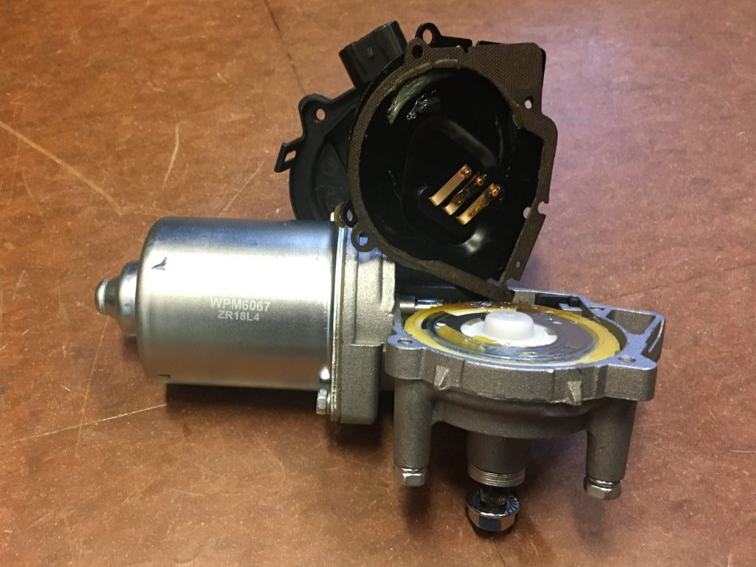

[**REGISTER**](https://e-vent.mit.edu/register/)  
[**LOGIN**](https://e-vent.mit.edu/login/)

Principio del formulario

Search for:

Final del formulario

**NEWS**

* [Updated Electrical & Operations](https://e-vent.mit.edu/updated-electrical-operations/)
* [FDA Ventilator Guidance](https://e-vent.mit.edu/fda-ventilator-guidance/)
* [FDA Releases Letter Regarding Ventilators](https://e-vent.mit.edu/fda-releases-letter-regarding-ventilators/)

**RECENT COMMENTS**

* [Gary Rondeau](https://e-vent.mit.edu/user/grondeau/) on [Mechanical Design](https://e-vent.mit.edu/mechanical/" \l "comment-615)
* [Najim Mouadili](https://e-vent.mit.edu/user/nmouadili/) on [Mechanical Design](https://e-vent.mit.edu/mechanical/" \l "comment-614)
* [Greg Linder](https://e-vent.mit.edu/user/denverengineer/) on [Updated Electrical & Operations](https://e-vent.mit.edu/updated-electrical-operations/" \l "comment-613)
* [bob mcgrath](https://e-vent.mit.edu/user/synaption/) on [Controls & Electrical Design](https://e-vent.mit.edu/controls/" \l "comment-612)
* [Vinicius Marini](https://e-vent.mit.edu/user/marinivk/) on [Downloads](https://e-vent.mit.edu/resources/downloads/" \l "comment-611)

**TERMS AND CONDITIONS**

[Read the terms of use for this website](https://e-vent.mit.edu/terms-and-conditions/)

Copyright © 2020 MIT E-Vent | MIT Emergency Ventilator. All Rights Reserved. Theme by [Aca](https://www.academiathemes.com/" \o "WordPress Themes for Schools and NGOs" \t "_blank)